**Index.html** is the main file

And pls open the xampp crontroller and start aparch and mysQL …then paste the floder in windows c(xampp folder ) ,there are a htdocs file past the whole folder there.

Then run the index.html ….other wise when you click the booking online tab there are some problem .

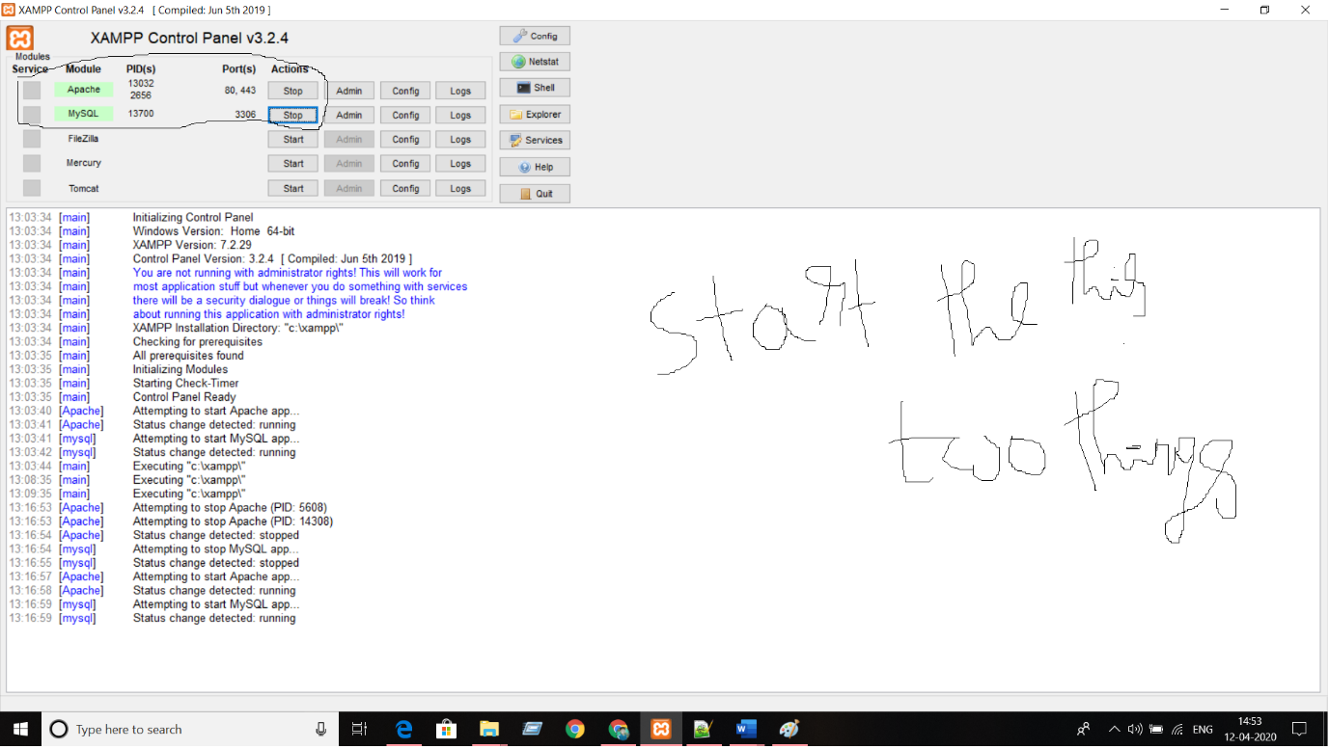

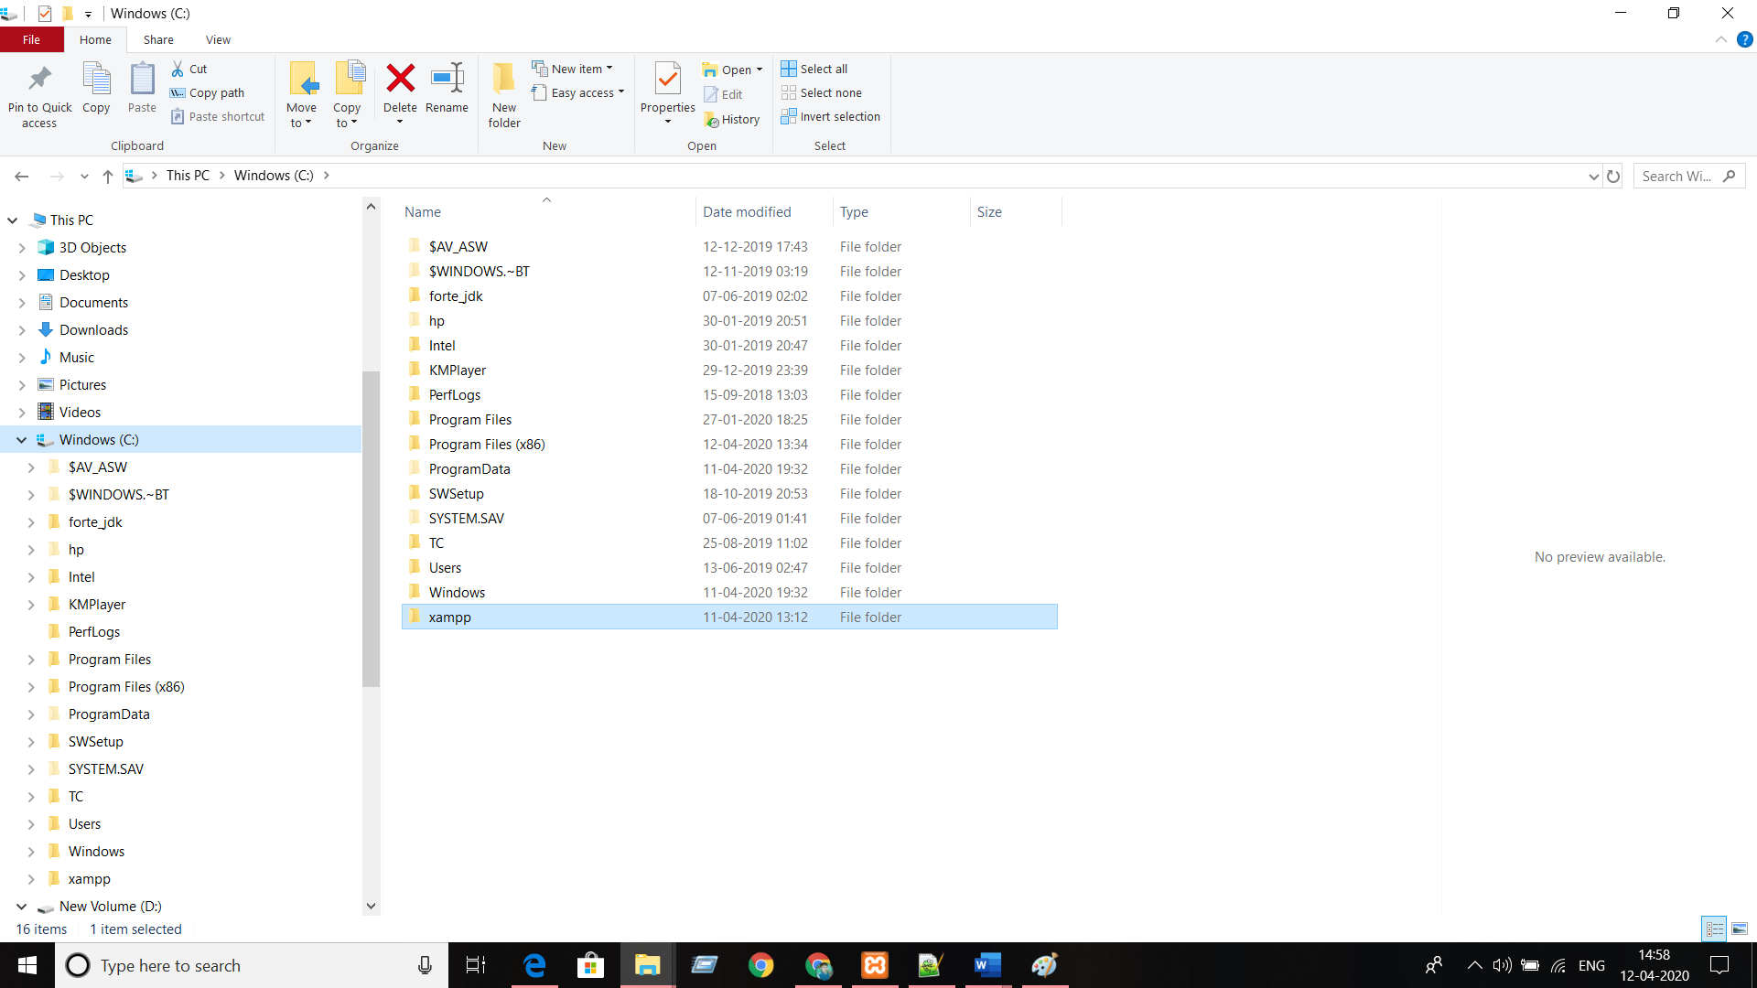

In xampp there is a htdocs file

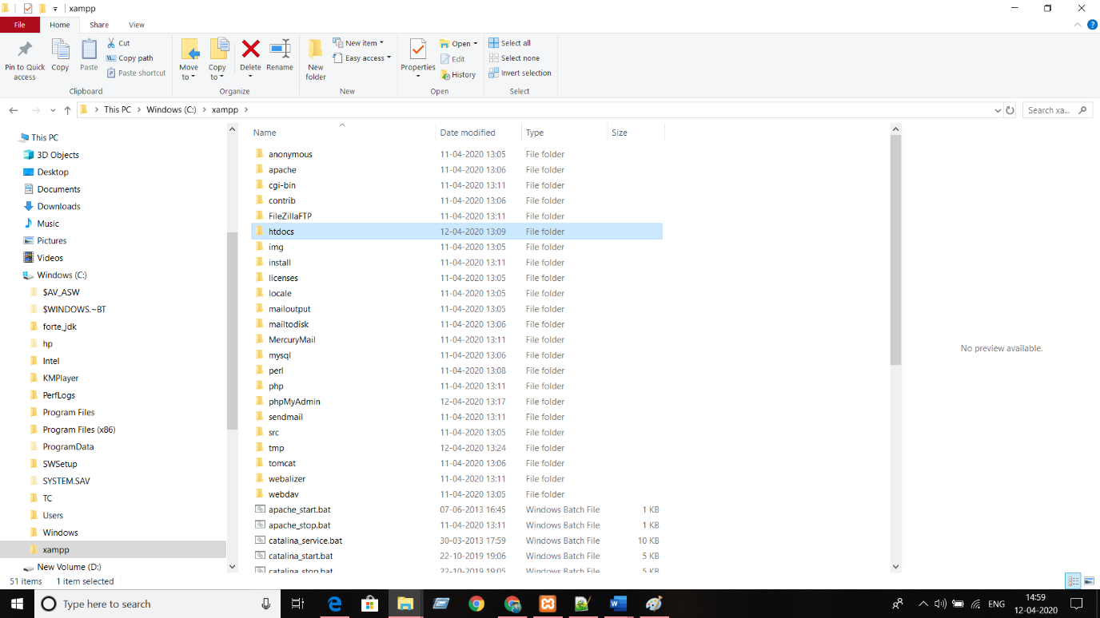

Paste the full file salon here.

Then run the index.html file